Logbook Week 8
March 10, 2026

On the eighth week we:
- Moved the table to the room we’re working in, but we’re still seeing if we can get permission to leave it permanently there.
- We booted up the robot and got a preliminary introduction to the software on the teach pendant.
- We tested the rice rollers to see how it would work with the rice:
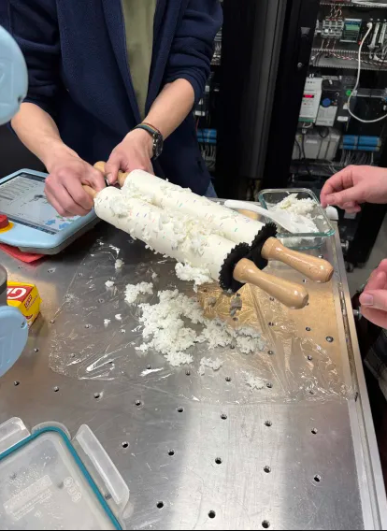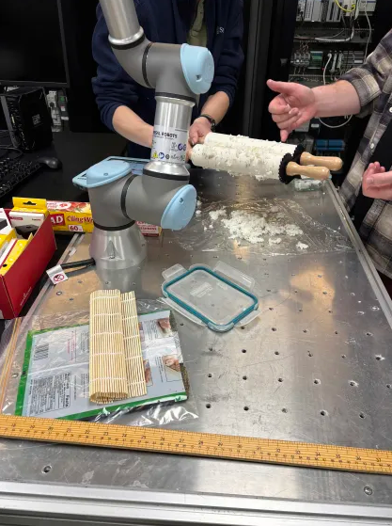
- It was fun but messy. We came up with some design tweaks to acknowledge what we learned from this test run:
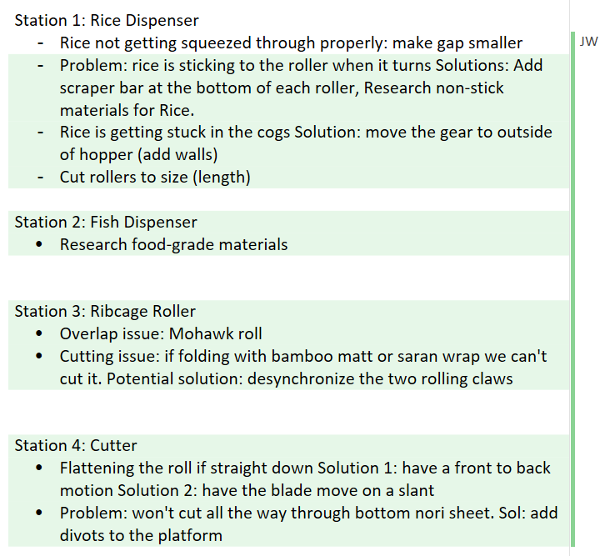
- The rice is really sticky and has a hard time getting through the rollers to lay a smooth sheet. That’s fine, we didn’t have great expectations for the sheet of rice. As long as the sushi gets rolled! Here’s our first-ever sushi roll with play-doh toppings:
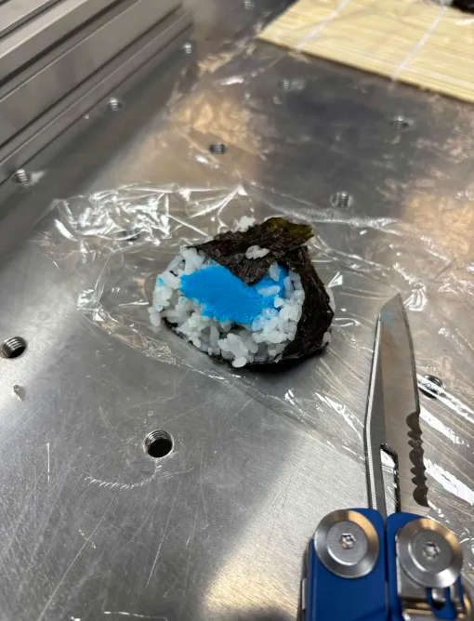
- Looks delicious, doesn’t it?
- We also finally decided on a length specification for the rail of the linear slide base: 1m
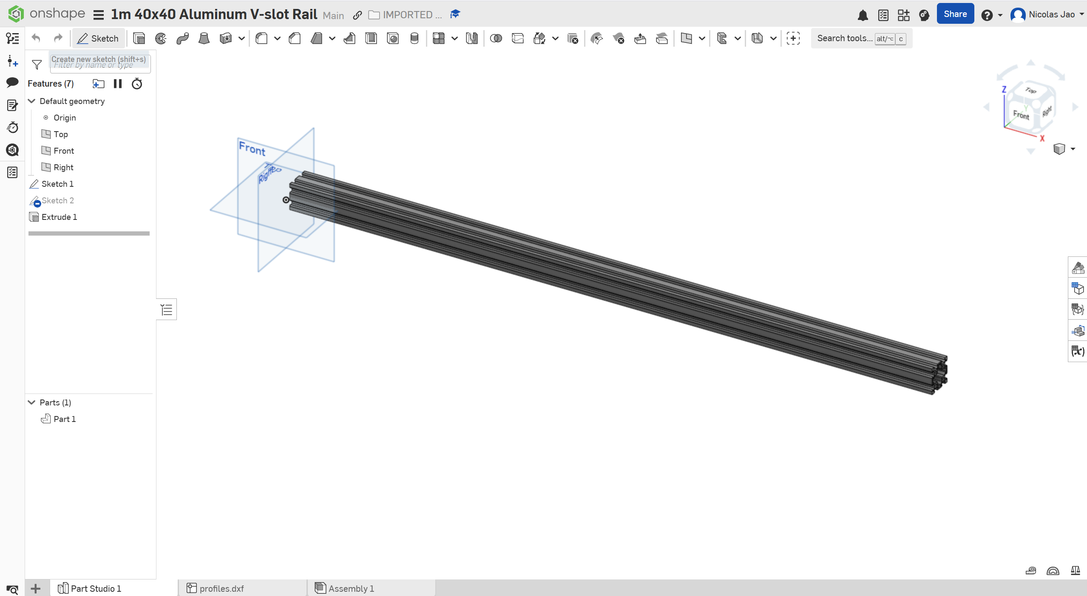
- Meaning we need a belt of at least 2 metres. We shopped for the belt and the rail and found how we can purchase them online. I plan to order them tonight.
- We also found a CAD for our stepper motors:
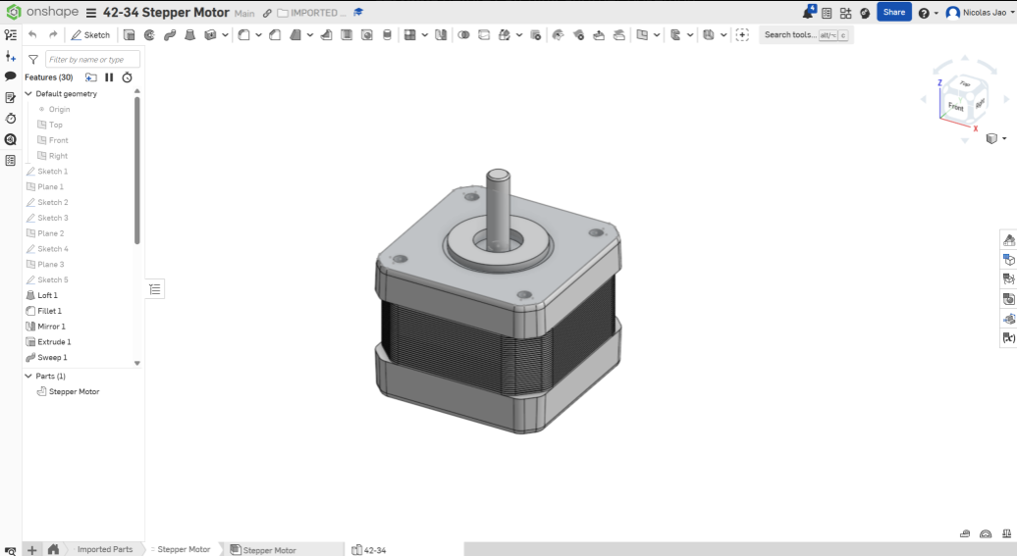
- I’m also finding parts for the rest of the station, such as the bearings and POM wheels and the bracket mount for the motor. Once I collect them all I can finally design it in CAD. For the most part, the linear slide base is done, we just need to 3D print a larger platform for the ribcage roller—and then the ribcage roller is a different station. Once we have all our parts we can also start assembling it on our table.
- We revisited our plan for motors. We decided that since we have 4 stepper motors on hand, and since they can do the job of a DC motor or servo, we are going to use them to save money by default. If during our process we find the motors are not strong enough or we need different specs, then we will buy new motors and redesign their mounts on the rails.
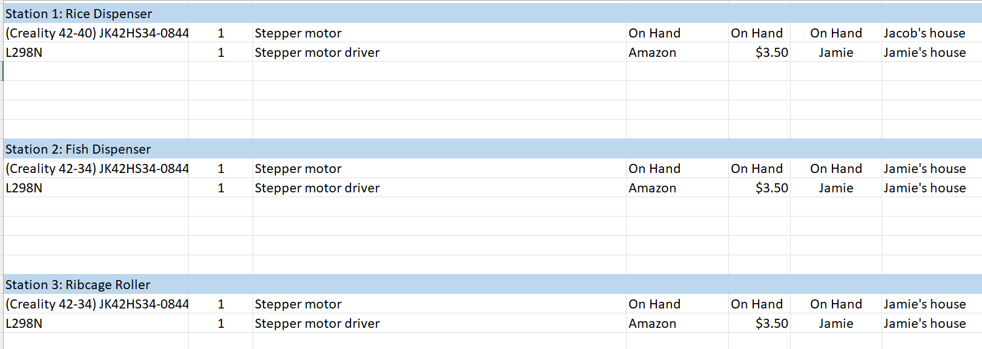

Things we will work on next week:
- Now that we’ve imported CAD parts and found what we need to order to complete the linear slide station, I plan to order the parts and depending on when they come, we can start assembling it (hopefully next week)
- We will continue working on the CAD design and specifications of the rice dispensing machine. I plan to dedicate time to figuring how to mount the rails on the table (will need L brackets probably), what fasteners (screws, nuts, and bolts) I’ll need, and how to mount the stepper motor for the rollers. For example, we need to find out the part number of this bracket, and find out if there are different configurations:
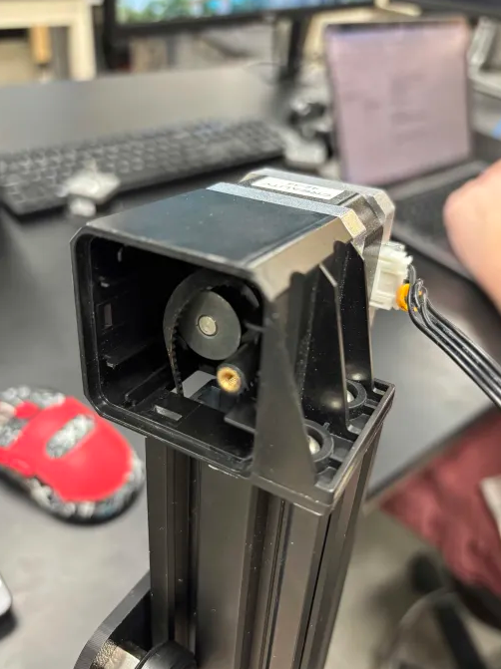
- Need to figure out what contact switches we want, how many we want, and how we’re going to mount them for the linear slide platform. Probably just a parallel rail. I’ll need to work on the CAD.
- We plan to give time to researching food-grade materials and how to make our process cleaner so the sushi can actually be safe to eat (probably stainless steel, or a resin coating on our materials)
- I need Jamie to import his CAD file of the ribcage roller from Fusion360 to Onshape so that I can start helping him on that. We plan to extend the platform and add extra holes for spaces for an elevated platform for the ribcage roller.

